Tactile Sensor

Objective within Prototype

The objective with this prototype would be a sensor that is able to detect any force applied to the neck of the guitar which would essentially replace the fretting of the guitar with a system that would require less force.

Ideas / Possibilities
Push Button
A push button is a device that can complete an electrical circuit when pressed. It consists of a spring that when pressed, connects wires, allowing current to flow [1].
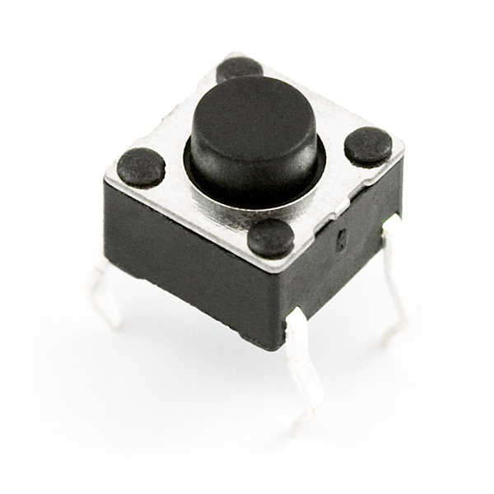
Figure 1: Push Button [2]

Some applications of push buttons [3] :
- Lights
- Calculators
- Telephones
- Kitchen appliances

Piezoelectric Tensile Sensor 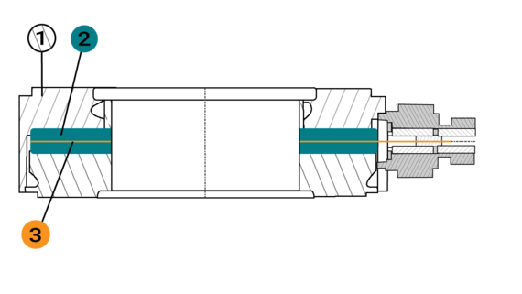
Figure 2: Drawing of Piezoelectric Tensile Sensor [4]

Components [4]
- Housing
- Piezoelectric crystal
- Electrode

Functionality [6]
The housing is along the sensor’s platform and in dependent contact with the Piezoelectric crystal. Precise processing of the crystal and component surfaces come into contact with the crystal. This procedure enables the use of pre-stressed sensors. [6]

A piezoelectric sensor’s output signal is determined by applying force to the crystal which results in an output signal.

A charge Q is formed, measured in pC (10e12 C). The charge can be calculated using the equation: [6]
$Q=q_{xyz}⋅F$
Q → charge F → force $q_{xyz}$ → piezoelectric constant

Comparison Between Ideas
Table 1: Comparison Matrix for Ideas
Selection Criteria (for Arduino element) | Push Button | Piezoelectric Tensile Sensor
Minimum Strumming Force Required | ~ 1 lbs [7] | 10 lbs, 50 lbs, 100 lbs, 500 lbs, 1000 lbs, 5000 lbs  [8]
Ability to Detect Varying Dynamics (Range of Forces) | No | Yes  (0.050N) [9]  Up to 50N [10]  Higher than 50N would result to invalid/improper response
Cost | 4 / $1.00 [11] | $210 [12]

Implementation within Prototype
The sensor will be implemented in the guitar within the fretting section of the guitar (guitar’s neck) which would essentially replace the button prototype. It will offer more precision in terms of the location at which the user is fredding with the tactile compared to the button’s limited options. A more precision will result in a more accurate type of note played hence increasing its authenticity in comparison with the button system. Authenticity is one of our top priorities to maintain and implementing the tactile system would be a necessity if more time has been given in this project which is unfortunately not the case.

Source Extracts
[1] https://sciencing.com/push-switches-work-electrical-circuit-5030234.html
[2] https://besomi.com/shop/buttons-and-switches/mini-pushbutton-switch/
[3] https://blog.se.com/access-to-energy/2018/07/13/push-buttons-and-their-widel
y-used-applications-across-industries/
[4] https://www.hbm.com/en/6810/selection-guide-for-piezo-sensors/
[5] https://www.hbm.com/en/6810/selection-guide-for-piezo-sensors/
[6] https://www.hbm.com/en/6810/selection-guide-for-piezo-sensors/
[7] https://community.smartthings.com/t/how-to-determine-force-required-to-push
-a-door-or-button-or-lever/161757

[8] https://www.a-tech.ca/Product/Category/2/Load_Cells_Force_Transducers/?pa
ge=1&display=list
[9] https://journals.sagepub.com/doi/pdf/10.1177/1550147718767794#:~:text=The%
20converted%20value%20of%20the,a%20maximum%20of%20500%20g
[10] https://citeseerx.ist.psu.edu/viewdoc/download?doi=10.1.1.461.3692&rep=rep1&
type=pdf#:~:text=The%20maximum%20forces%20applied%20on,some%20of%20the%20sensing%20cells
[11] https://www.sparkfun.com/products/15326
[12] https://journals.sagepub.com/doi/10.1177/1729881418783631#:~:text=A%20tactil
e%20sensor%20with%20the,design%20including%20hardware%20and%20so
ftware

